DISTANCE AND DISPLACEMENT

Distance (d): how far a body moves in any direction.

e.g. The diagram below shows the movement of a student between home and school.

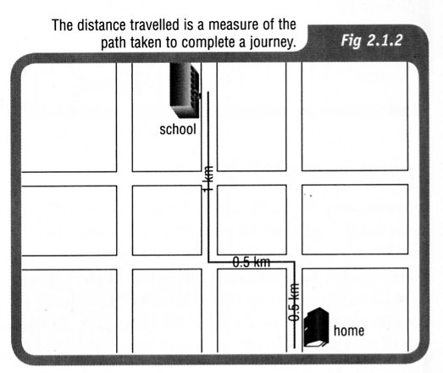

The distance travelled is 2.0 km.

Displacement (s): change of position of a body from the start of the motion to the finish of the
motion, and is in a particular direction.

e.g. The diagram below shows the displacement of the student when travelling to school.

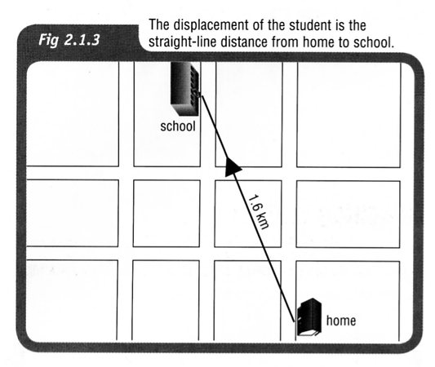

The straight-line distance is 1.6 km. No direction is indicated in the diagram.

If the distance you walk from home to school is 2 kilometres, the distance you travel
from home to school and back home again is 4 kilometres. If you start at home and
finish the day’s journey at home, your starting and finishing points are the same position
(home) then your displacement for the day is actually 0 km.

In Physics, distance is known as a scalar quantity and displacement is a vector quantity.

See the notes on Scalars and Vectors.

SPEED AND VELOCITY

Speed: distance moved per unit time.

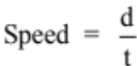

where speed = how fast the object travels for the entire journey (ms⁻¹)
d = distance travelled for the entire journey (m)
t = time taken for the entire journey (s)

Speed is a scalar quantity as direction is not important. Velocity is a vector quantity and has a direction involved.

Velocity: displacement moved in a given direction per unit time.

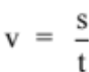

where v = velocity in a given direction (ms⁻¹)
s = displacement in a given direction (m)
t = time taken to move in a given direction (s)

Note
The units for speed and velocity are metres per second (ms⁻¹), not kmh⁻¹.

To convert kmh⁻¹ to ms-1, divide the reading in kmh⁻¹ by 3.6.

Example 1

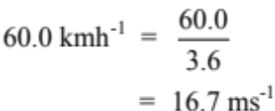
Example 2

A cyclist rides along a coast road that meanders and changes direction constantly. He covers a distance of 5.80 km in a time of 12.2 minutes. However the straight line distance between his start and finish points is only 4.20 km in a direction due south. Calculate:

(a) the average speed of the cyclist.
(b) his average velocity.
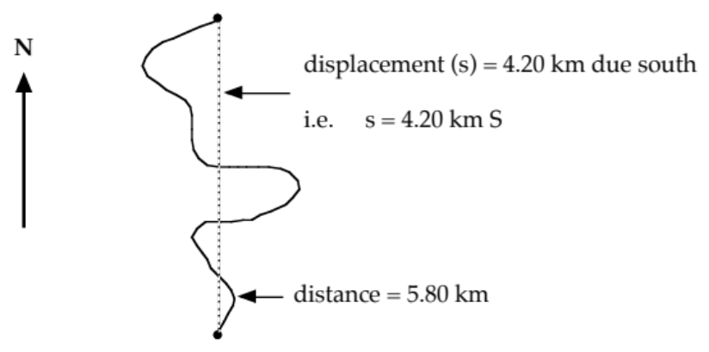

(a) (b)
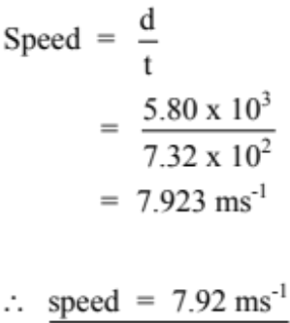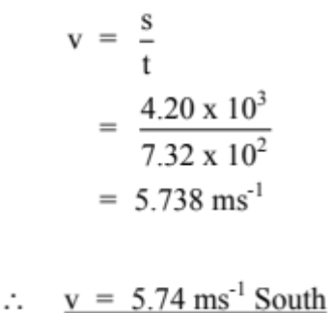

The direction is important - make sure you put it in!

